

**1.** [*In this question, position vectors are given relative to a fixed origin*.]

At time *t* seconds, where *t* > 0 , a particle *P* has velocity **v** m s–1 where

**v** = 3*t*2**i** – 6**j**

(*a*)Find the speed of *P* at time *t* = 2 seconds.

**(2)**

(*b*)Find an expression, in terms of *t*, **i** and **j**, for the acceleration of *P* at time *t* seconds,

where *t* > 0

**(2)**

At time *t* = 4 seconds, the position vector of *P* is (**i** – 4**j**) m.

(*c*)Find the position vector of *P* at time *t* = 1 second.

**(4)**

**(Total for Question 1 is 8 marks)**

**___________________________________________________________________________**

**2.**

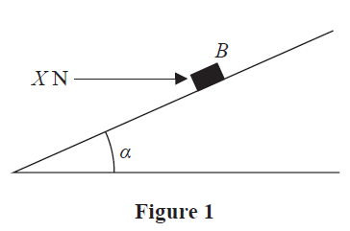

A rough plane is inclined to the horizontal at an angle *α*, where tan *α* = 

A small block *B* of mass 5 kg is held in equilibrium on the plane by a horizontal force of

magnitude *X* newtons, as shown in Figure 1.

The force acts in a vertical plane which contains a line of greatest slope of the inclined

plane.

The block *B* is modelled as a particle.

The magnitude of the normal reaction of the plane on *B* is 68.6 N.

Using the model,

(*a*)(i) find the magnitude of the frictional force acting on *B*,

**(3)**

(ii) state the direction of the frictional force acting on *B*.

**(1)**

The horizontal force of magnitude *X* newtons is now removed and *B* moves down

the plane.

Given that the coefficient of friction between *B* and the plane is 0.5

(*b*)find the acceleration of *B* down the plane.

**(6)**

**(Total for Question 2 is 10 marks)**

**___________________________________________________________________________**

**3.** [*In this question*, **i** *and* **j** *are horizontal unit vectors*.]

A particle *P* of mass 4 kg is at rest at the point *A* on a smooth horizontal plane.

At time *t* = 0, two forces, **F**1 = (4**i** – **j**) N and **F**2 = (*λ***i** + *μ***j**) N , where *λ* and *μ* are

constants, are applied to *P*

Given that *P* moves in the direction of the vector (3**i** + **j**)

(*a*)show that

*λ* – 3*μ* + 7 = 0

**(4)**

At time *t* = 4 seconds, *P* passes through the point *B*.

Given that *λ* = 2

(*b*)find the length of *AB*.

**(5)**

**(Total for Question 3 is 9 marks)**

**___________________________________________________________________________**

**4.**

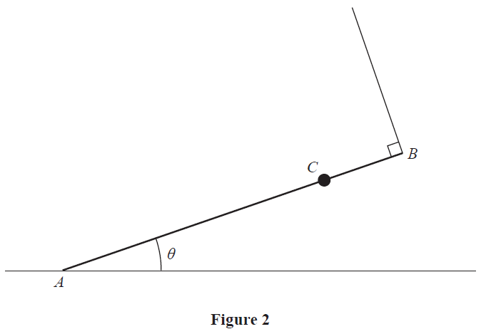

A uniform rod *AB* has mass *M* and length 2*a*

A particle of mass 2*M* is attached to the rod at the point *C*, where *AC* = 1.5*a*

The rod rests with its end *A* on rough horizontal ground.

The rod is held in equilibrium at an angle *θ* to the ground by a light string that is

attached to the end *B* of the rod.

The string is perpendicular to the rod, as shown in Figure 2.

(*a*)Explain why the frictional force acting on the rod at *A* acts horizontally to the right

on the diagram.

**(1)**

The tension in the string is *T*

(*b*)Show that *T* = 2*M*g cos *θ*

**(3)**

Given that cos *θ* = 

(*c*)show that the magnitude of the vertical force exerted by the ground on the rod at *A*

is 

**(3)**

The coefficient of friction between the rod and the ground is *μ*

Given that the rod is in limiting equilibrium,

(*d*)show that *μ* = 

**(4)**

**(Total for Question 4 is 11 marks)**

**___________________________________________________________________________**

**5.**

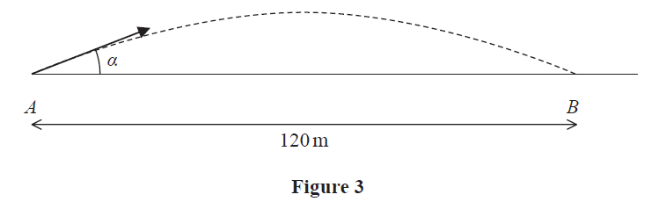

A golf ball is at rest at the point *A* on horizontal ground.

The ball is hit and initially moves at an angle *α* to the ground.

The ball first hits the ground at the point *B*, where *AB* = 120 m, as shown in Figure 3.

The motion of the ball is modelled as that of a particle, moving freely under gravity,

whose initial speed is *U* m s–1

Using this model,

(*a*)show that *U*2 sin *α* cos *α* = 588

**(6)**

The ball reaches a maximum height of 10 m above the ground.

(*b*)Show that *U*2 = 1960

**(4)**

In a refinement to the model, the effect of air resistance is included.

The motion of the ball, from *A* to *B*, is now modelled as that of a particle whose initial

speed is *V* m s–1

This refined model is used to calculate a value for *V*

(*c*)State which is greater, *U* or *V*, giving a reason for your answer.

**(1)**

(*d*)State one further refinement to the model that would make the model more realistic.

**(1)**

**(Total for Question 5 is 12 marks)**

**___________________________________________________________________________**

**TOTAL FOR MECHANICS IS 50 MARKS**