

**1.** George throws a ball at a target 15 times.

Each time George throws the ball, the probability of the ball hitting the target is 0.48

The random variable *X* represents the number of times George hits the target in

15 throws.

(*a*)Find

(i) P (*X* = 3)

(ii) P (*X ≥*  5)

**(3)**

George now throws the ball at the target 250 times.

(*b*)Use a normal approximation to calculate the probability that he will hit the target

more than 110 times.

**(3)**

**(Total for Question 1 is 6 marks)**

**___________________________________________________________________________**

**2.** A manufacturer uses a machine to make metal rods.

The length of a metal rod, *L* cm, is normally distributed with

• a mean of 8 cm

• a standard deviation of *x* cm

Given that the proportion of metal rods less than 7.902 cm in length is 2.5%

(*a*)show that *x* = 0.05 to 2 decimal places.

**(2)**

(*b*)Calculate the proportion of metal rods that are between 7.94 cm and 8.09 cm

in length.

**(1)**

The **cost** of producing a single metal rod is 20p

A metal rod

• where *L* < 7.94 is **sold** for scrap for 5p

• where 7.94 ≤ *L* ≤ 8.09 is **sold** for 50p

• where *L* > 8.09 is shortened for an extra **cost** of 10p and then **sold** for 50p

(*c*)Calculate the expected profit per 500 of the metal rods.

Give your answer to the nearest pound.

**(5)**

The same manufacturer makes metal hinges in large batches.

The hinges each have a probability of 0.015 of having a fault.

A random sample of 200 hinges is taken from each batch and the batch is accepted if

fewer than 6 hinges are faulty.

The manufacturer's aim is for 95% of batches to be accepted.

(*d*)Explain whether the manufacturer is likely to achieve its aim.

**(4)**

**(Total for Question 2 is 12 marks)**

**___________________________________________________________________________**

**3.** Dian uses the large data set to investigate the Daily Total Rainfall, *r* mm, for Camborne.

(*a*)Write down how a value of 0 < *r* ≤ 0.05 is recorded in the large data set.

**(1)**

Dian uses the data for the 31 days of August 2015 for Camborne and calculates the

following statistics

*n* = 31 = 174.9 = 3523.283

(*b*)Use these statistics to calculate

(i) the mean of the Daily Total Rainfall in Camborne for August 2015,

(ii) the standard deviation of the Daily Total Rainfall in Camborne for August 2015.

**(3)**

Dian believes that the mean Daily Total Rainfall in August is less in the South of the

UK than in the North of the UK.

The mean Daily Total Rainfall in Leuchars for August 2015 is 1.72 mm to 2 decimal

places.

(*c*)State, giving a reason, whether this provides evidence to support Dian's belief.

**(2)**

Dian uses the large data set to estimate the proportion of days with no rain in Camborne

for 1987 to be 0.27 to 2 decimal places.

(*d*)Explain why the distribution B(14, 0.27) might **not** be a reasonable model for the

number of days without rain for a 14‑day summer event.

**(1)**

**(Total for Question 3 is 7 marks)**

**___________________________________________________________________________**

**4.** A dentist knows from past records that 10% of customers arrive late for

their appointment.

A new manager believes that there has been a change in the proportion of customers

who arrive late for their appointment.

A random sample of 50 of the dentist's customers is taken.

(*a*)Write down

• a null hypothesis corresponding to no change in the proportion of customers

who arrive late

• an alternative hypothesis corresponding to the manager's belief

**(1)**

(*b*)Using a 5% level of significance, find the critical region for a two-tailed test of the

null hypothesis in (*a*)

You should state the probability of rejection in each tail, which should be less

than 0.025

**(3)**

(*c*)Find the actual level of significance of the test based on your critical region from

part (*b*)

**(1)**

The manager observes that 15 of the 50 customers arrived late for their appointment.

(*d*)With reference to part (*b*), comment on the manager’s belief.

**(1)**

**(Total for Question 4 is 6 marks)**

**___________________________________________________________________________**

**5.** A company has 1825 employees.

The employees are classified as professional, skilled or elementary.

The following table shows

• the number of employees in each classification

• the two areas, *A* or *B*, where the employees live

|  |  |  |
| --- | --- | --- |
|  | ***A*** | ***B*** |
| **Professional** | 740 | 380 |
| **Skilled** | 275 | 90 |
| **Elementary** | 260 | 80 |

An employee is chosen at random.

Find the probability that this employee

(*a*)is skilled,

**(1)**

(*b*)lives in area *B* and is not a professional.

**(1)**

Some classifications of employees are more likely to work from home.

• 65% of professional employees in both area *A* and area *B* work from home

• 40% of skilled employees in both area *A* and area *B* work from home

• 5% of elementary employees in both area *A* and area *B* work from home

• Event *F* is that the employee is a professional

• Event *H* is that the employee works from home

• Event *R* is that the employee is from area *A*

(*c*)Using this information, complete the Venn diagram on the next page.

**(4)**

(*d*)Find P (*R'* ∩ *F*)

**(1)**

(*e*)Find P ([*H* ∪ *R*]*'* )

**(1)**

(f) Find P (*F* | *H* )

**(2)**

**(Total for Question 5 is 10 marks)**

**___________________________________________________________________________**

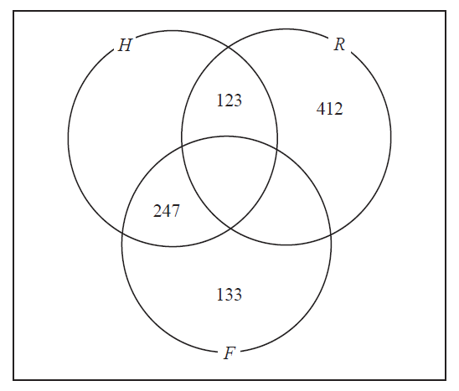

**6.** Anna is investigating the relationship between exercise and resting heart rate.

She takes a random sample of 19 people in her year at school and records for

each person

* their resting heart rate, *h* beats per minute
* the number of minutes, *m*, spent exercising each week

Her results are shown on the scatter diagram.

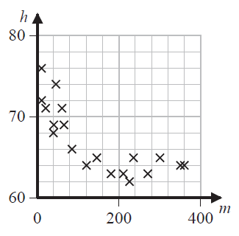

(*a*)Interpret the nature of the relationship between *h* and *m*

**(1)**

Anna codes the data using the formulae

*x* = log10 *m*

*y* = log10 *h*

The product moment correlation coefficient between *x* and *y* is – 0.897

(*b*)Test whether or not there is significant evidence of a negative correlation

between *x* and *y*

You should

• state your hypotheses clearly

• use a 5% level of significance

• state the critical value used

**(3)**

The equation of the line of best fit of *y* on *x* is

*y* = – 0.05*x* + 1.92

(*c*)Use the equation of the line of best fit of *y* on *x* to find a model for *h* on *m* in

the form

*h* = *am k*

where *a* and *k* are constants to be found.

**(5)**

**(Total for Question 6 is 9 marks)**

**___________________________________________________________________________**

**TOTAL FOR STATISTICS IS 50 MARKS**